Decision Guidance Toolkit for People-Centered Integration of Health Campaigns

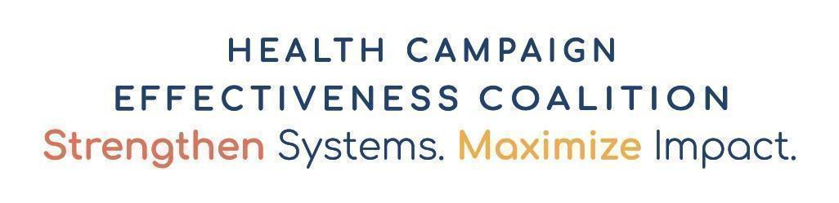
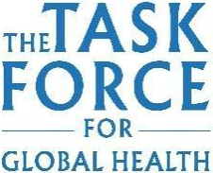
April 2021 (Draft0)

Background
Health campaigns are time-bound, intermittent activities that address specific epidemiologic challenges, expediently fill delivery gaps, or provide surge coverage for health interventions. Many campaigns complement routine health service delivery. Campaigns occur in health areas, such as malaria, neglected tropical diseases (NTDs), immunization, polio, and Vitamin A supplementation. They can be used to prevent or respond to disease outbreaks, control or eliminate targeted diseases as a public health problem, eradicate a disease altogether, or achieve other health goals.

Despite the many successes of health campaigns, current vertical approaches can limit their potential impact. In settings where multiple campaigns occur, planning and implementation may be carried out with little communication or collaboration among stakeholders and with inadequate coordination with country health systems. This may result in inefficiencies and inequities that can strain health systems, burden health care workers and communities, weaken health services, and limit the potential impact of campaigns.

The Health Campaign Effectiveness program (HCE) at The Task Force for Global Health with support from the Bill & Melinda Gates Foundation has developed a cross-campaign coalition that fosters learning and systems change. The Coalition brings together country leaders, donors, multilateral organizations, and NGOs from several large-scale health campaign domains, as well as specialists in health systems, ethics, and health economics.

Purpose and Objectives of this Toolkit
The purpose of the toolkit is to assist diverse officials and stakeholders at the country and global levels to identify and collect information on the potential opportunities for health campaign integration.

The objectives are to:
- Identify opportunities for initiating and continuing a discussion on campaign integration;
- Provide evidence-based criteria to help country health programs and stakeholders pair campaign interventions with strong promise for effective full or partial integration;
- Highlight the factors that are potential facilitators and barriers to such combinations in each country context; and
- Facilitate the synthesis of global and national guidelines, standards, and criteria to inform campaign integration decisions in each country.
While not exhaustive, the two appendices--Worksheet for Global and Country Standards on Planning Health Campaign Integration and Criteria across Health Domains and Specific Interventions for Selecting Potential Campaign Integration—can be particularly helpful for the pre-planning stages of campaign integration.

Users
The intended users are policy makers and stakeholders at the national, subnational, regional, and global levels who oversee, plan, finance, implement, or monitor health campaigns, and that issue guidance around health campaigns, PHC, and health systems strengthening.

In developing this tool, special attention was dedicated to upholding the key categories of Feasibility, Accountability, Acceptability, Compatibility, Context, and Equity (see Appendix C).

Acknowledgements

The Decision Guidance Toolkit for People-Centered Integration of Health Campaigns was developed by the Health Campaign Effectiveness program, generously funded by the Bill and Melinda Gates Foundation at the Task Force for Global Health. The toolkit was informed by discussions of the Campaign Integration Working Group (CIWG) through an iterative process of feedback gleaned from CIWG meetings, subject matter experts, field experience, HCE funded case studies, and guidelines of the World Health Organization.

The document was developed by David Gittelman, Vivek Patel, and Eva Bazant. We thank CIWG members for specific comments on and inputs to this tool, including Andreas Hasman, UNICEF; Anitta Kamara of National Malaria Control Programme, Ministry of Health and Sanitation, Sierra Leone; Mandy Kader Kondé la Fondation Santé & Développement Durable/Centre d'Excellence de Formation et Recherche sur les Maladies Prioritaires in Guinea; Patrick Lammie, of the NTD-Support Center at the Taskforce for Global Health; Gladys Muhire and Suzanne Van Hulle, Catholic Relief Services; Laura Nic Lochlainn, World Health Organization; Pooja Pandey, Helen Keller International, Nepal; Robert Perry, Centers for Disease Control and Prevention, Atlanta, Georgia, USA; Martha Saboya, Pan American Health Organization; and Jovana Alexandra Ocampo Cañas, Universidad de los Andes, Bogotá, Colombia. We acknowledge CIWG members for engaging in discussions related to the toolkit, including Zainab Ali, Catholic Relief Services, Nigeria; Horace Cox, Ministry of Health, Guyana; Ajay Khera, EngenderHealth India; Alison Krentel, Bruyere Research Institute, University of Ottawa, Canada; Htar Htar Lin, Ministry of Health and Sports, Myanmar; Joseph Oteri, National Primary Health Care Development Agency, Nigeria; Sara Sa Silva, Gavi Secretariat; and Kwamy Togbey, Ministry of Health, Togo.
Suggested Citation: Gittelman D, Patel V, Bazant E and the Campaign Integration Working Group of the Health Campaign Effectiveness Coalition. Decision Guidance Toolkit for People-Centered Integration of Health Campaigns. Decatur, GA: The Task Force for Global Health, 2021.

Decision Guidance Toolkit for People-Centered Integration of Health Campaigns (April 2021-Draft 0)

Table of Contents
How to use the Decision Guidance Toolkit for People-Centered Integration of Health Campaigns 1
How Do You Start or Continue the Conversation on Campaign Integration in Your Country? 2
Decision Guidance Tool to Identify Facilitators and Barriers for Full Campaign Integration/Co-delivery, by Health Intervention 3
Key Criteria for People-Centered Integration Decisions at Various Levels 4
Example and Sample Pairings of Health Interventions 5
Appendix A: Worksheet for Global and Country Standards on Planning Health Campaign Integration 7
Appendix B: Criteria across Health Domains and Specific Interventions for Selecting Potential Campaign Integration 9
Appendix C: Key Categories of Considerations for Campaign Integration 24
Abbreviations/Acronyms 25
Definitions of Criteria (illustrative) 26
References (draft) 28

How to use the Decision Guidance Toolkit for People-Centered Integration of Health Campaigns
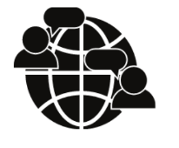 | Step 1: Identify the Problem & Start or Continue the Conversation  The first step is one of assessment and reflection on the potential for integrating campaigns. Please see the tool on page 2 for suggested best practices and tips to generate or build interest: “How do you start or continue the conversation on campaign integration in your country?”.  Step 2: Explore the Possibilities and Identify Pairings  Once you have convened key decision-makers and partners to the idea of integration, the next step is to explore other health interventions from the perspective of your current role (e.g., local district, country, or global level).  - Start by reviewing the overview matrix tool on page 3. This tool gives a visual representation of how to explore the pairing of different health interventions and identifying the facilitators and barriers to each combination.  - Next, review on page 4 the table “Key Criteria for People-Centered Integration Decisions at Various Levels.” The purpose of the tool is to suggest key criteria that decision-makers from the global to local levels should consider for pairing campaign interventions. Each criterion could be a facilitator or barrier, depending on the health intervention and country context.  - Examine the campaign pairing examples for facilitators and barriers on pages 5 and 6. This tool should stimulate ideas for applying the matrix and key criteria.  Step 3: Customize According to Global, Country, and/or Local Context  Once you have identified possible health intervention(s) for integration, the next step is to customize the integration using more detailed technical and operational considerations.  - Assemble existing global or national policies and standards, as well as the sub-national or local contexts, to further assess whether integration is feasible and appropriate. Global guidance on key health interventions is available on the websites of WHO, PAHO, UNICEF and their key global partners such as GAVI and the Global Fund for HIV, TB and Malaria. Campaign integration strategies and plans of action should reflect this information.  - Use Appendix A on page 7, “Worksheet for Global and Country Standards on Planning Health Campaign Integration”. Fill in the cells based on the suggested criteria to help this decision and planning process.  - Review the more detailed technical and operational criteria and best practices involved in integrations suggested in Appendix B on page 9, “Criteria Across Health Domains and Specific Interventions for Selecting Potential Campaign Integration.” While the table incorporates the latest global guidance and experience available when this tool was developed (see References), the list of criteria to consider is not exhaustive and should be modified to the country context and updated, as needed.  After completing this process of review and reflection, national programs and their partners are ready to decide whether campaign integration of specific health interventions is promising. After using the Decision Guidance Toolkit for People-Centered Integration of Health Campaigns, national programs and their partners can begin collaborating on strategic planning.
Step 1: Identify the Problem & Start or Continue the Conversation

How Do You Start or Continue the Conversation on Campaign Integration in Your Country?
Before using the toolkit to examine integration opportunities, key decision-makers and partners in a country need to be attracted to the idea of campaign integration and motivated to explore it further. Here are some tips to help start or continue the conversation.
 | Identify the problem  Pinpoint the challenges you face in planning a campaign. Are they limited funding, staff overwhelmed by overlapping campaigns and routine duties, poor intervention coverage, disease outbreaks, or others?  Determine if integrating campaigns is a viable way to address those problems  Research whether the country has conducted integrated campaigns in the past, and if so, whether they were conducted well and met their targets. Ask staff who participated in those campaigns to share their experience. Locate and review previous campaign reports and tools. Learn if different health programs have shared strategies and tools on certain parts of the campaign process such as microplanning, population census, logistics, communications or data collection; perhaps collaboration or partial-integration is more promising than co-delivery or full integration.  Engage leaders with the qualities and clout needed to generate interest in campaign integration.  Cultivate relationships with leaders and other individuals who have the knowledge, peer-recognition, and humility that can spark change. Look for key qualities such as: availability, accountability, spirit of advocacy, transparency, and ability to delegate  Identify the key decision-makers with the legal or administrative authority to approve an integrated strategy and/or to fund those efforts.  Consult Government Ministries of Health, Finance, and Education where appropriate, along with key implementing partners who typically help finance the targeted health interventions. |  |  | Ensure equity by reaching out to a broad array of stakeholders at the national, district and community levels in exploring campaign integration.  Include stakeholders such as health workers, community, faith and traditional leaders, community agents, medical and nursing organizations, academic institutions, and faith-based agencies. Include both supporters and opponents of integration. Take care to encourage constructive dialogue rather than imposing solutions.  Encourage individuals or organizations in-country that express interest in campaign integration to start the conversation.  Suggest or seek guidance on the best timing, setting and group of individuals or organizations for that conversation. Outline the objectives of those initial discussions and incorporate the decision-making process described below in the agenda and work plan.  Select an optimal setting for the conversation  Take advantage of routine coordination meetings of the Ministry of Health and partners to include integration on the agenda. Bring this toolkit!

Step 2a: Explore the Possibilities and Identify Pairings - This tool gives a visual representation of how to explore the pairing of different health interventions by facilitators and barriers to each combination.

Decision Guidance Tool to Identify Facilitators and Barriers for Full Campaign Integration/Co-delivery, by Health Intervention
Health Intervention | Immunization |  |  |  |  | Malaria |  | Neglected Tropical Diseases |  |  |  |  | Nutrition
 | OPV | IPV | MCV | Men | YF | ITNs | SMC | LF | Oncho | SS | STH (deworming) | Trach | VitA | Maln
Polio (OPV) |  |  | Facilitator:  Barrier: | Facilitator:  Barrier: | Facilitator:  Barrier:
Polio (IPV) |  |  | Facilitator:  Barrier: | Facilitator:  Barrier: | Facilitator:  Barrier:
Measles (MCV) |  |  |  | Facilitator:  Barrier: | Facilitator:  Barrier:
Meningitis (Men) |  |  |  |  | Facilitator:  Barrier:
Yellow Fever (YF)
Insecticide-Treated Nets (ITNs)
Seasonal Malaria Chemoprevention (SMC)
Lymphatic Filariasis (LF)
Onchocerciasis (Oncho)
Schistosomiasis (SS)
Soil-Transmitted Helminths (STH)
Trachoma (Trach)
Vitamin A (VitA)
Assessment of Severe Malnutrition (Maln)
Step 2b: Explore the Possibilities and Identify Pairings - The purpose of the tool is to suggest key criteria that decision-makers from the global to local levels should consider for pairing campaign interventions. Each criterion could be a facilitator or barrier, depending on the health intervention and country context.

Key Criteria for People-Centered Integration Decisions at Various Levels
(Note: Please see page 26 for definitions of selected criteria)
Intervention  - Age Range  - Seasonality  - Intervention complexity (e.g. injectable cold chain, directly observed therapy)  - Place of delivery and distribution mode  - Duration/frequency (recurring, rotating, one time, catch up) | Local/Subnational  - Community acceptance of all individual interventions & of integration  - Health worker acceptance of all individual interventions & of integration  - Community capacity to ensure effective integration (e.g., training)  - Incentives for integration (e.g. monetary or non-monetary)  - Communication in place (e.g. to address rumors, hesitancy)  - Equity (e.g. access, gender, human rights)  - Values (active community participation throughout planning/implementation)  - Preferences of caregivers/families/beneficiaries  - Local epidemiology of targeted health intervention  - Capacity to monitor post campaign adverse events if applicable | National  - Government commitment & policy  - Coordination mechanisms, including public health workforce  - Incentives or willingness to explore integration  - Financing by government & donors  - Options and feasibility for pooling partner resources to support integration  - Geographic overlap of campaign per program  - Population acceptance of individual interventions & principles of integration  - Operational complexity (procurement, supply chain, logistics, communications, waste management)  - Equal priority given to each intervention being co-delivered  - Capacity for & commitment to monitoring, data collection, evaluation, surveillance  - Duration & Frequency (recurring, rotating, one-time)  - Partial integration (census data, social mobilization, education, messaging)  - Planning or implementation of other health campaigns  - Planning for monitoring post campaign adverse events if applicable | Global  - Global partner dialogue facilitation (e.g., HCE Coalition, WHO)  - Global policy & operational guidance  - Equal priority given to each intervention being co-delivered  - Linkage to global/regional goals & local/regional priorities  - Structural barriers  - Advocacy, programmatic Incentives for integration  - Awareness of other campaign interventions being planned or in progress.  - Monitoring post campaign adverse events if applicable

Step 2c: Explore the Possibilities and Identify Pairings - This tool depicts campaign pairing examples for facilitators and barriers and should stimulate ideas for applying the matrix and key criteria.
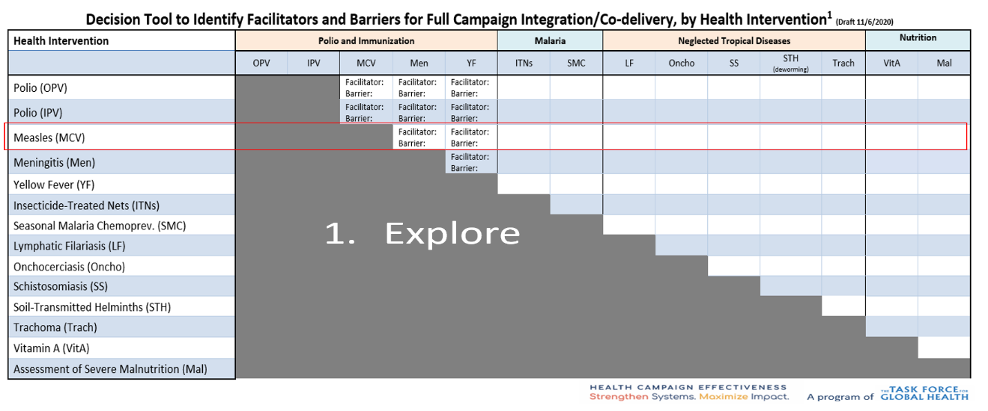
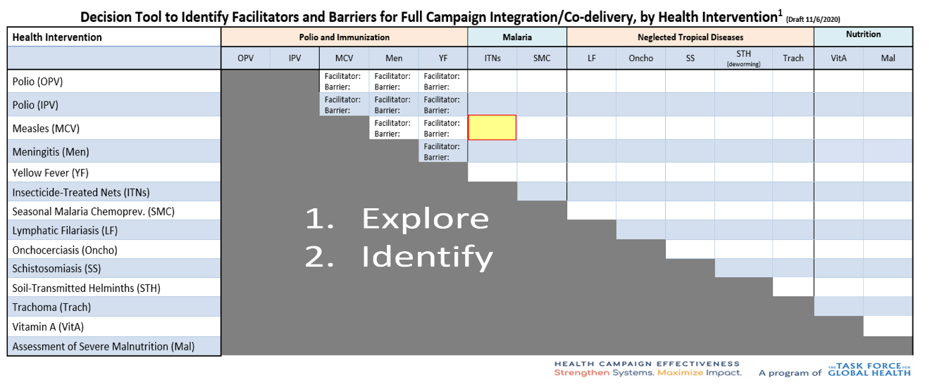
Example and Sample Pairings of Health Interventions
Step 3 -“Zoom-In”: Once possible pairings or bundles of interventions have been identified, “zoom-in” and identify specific facilitators and barriers from the key criteria on page 5, Appendix A, and Appendix B.
An example of the pre-planning for integration between a measles and malaria ITN campaign is shown below with key facilitators and barriers identified.

Step 1 - Explore: Explore other health interventions from the perspective of your current role (e.g. local district, country, or global level).
For example, country or state-level planners of a Measles immunization campaign would research planned/ongoing campaigns in their country (e.g., immunizations, malaria, NTDs, and VitA).

Step 2 - Identify Pairings: Identify a specific campaign(s) that may be a possible target for integration.
A planner of an immunization campaign may identify Malaria ITN’s as a potential fit. Alternatively, a VitA campaign manager may identify STH as a potential fit.

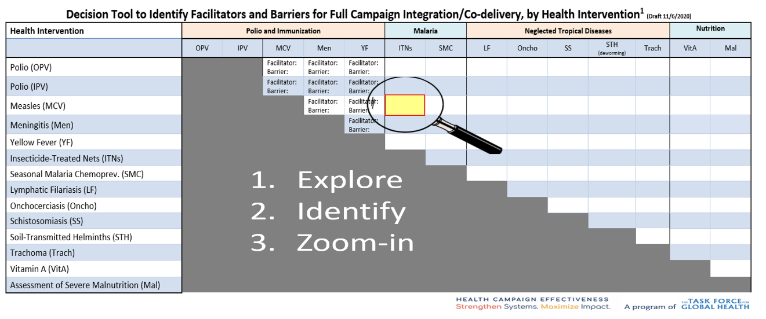
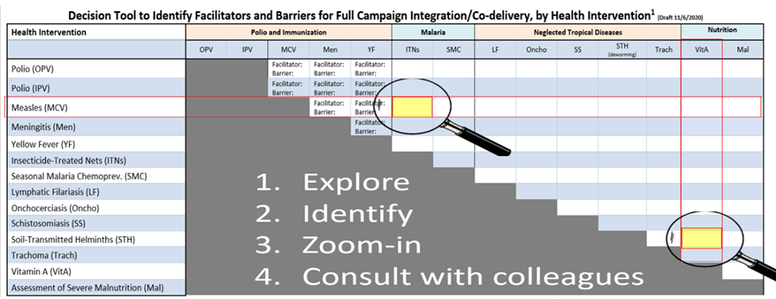

Step 4- Consult with Colleagues in the departments that oversee the campaigns on the key facilitators and barriers for integration.

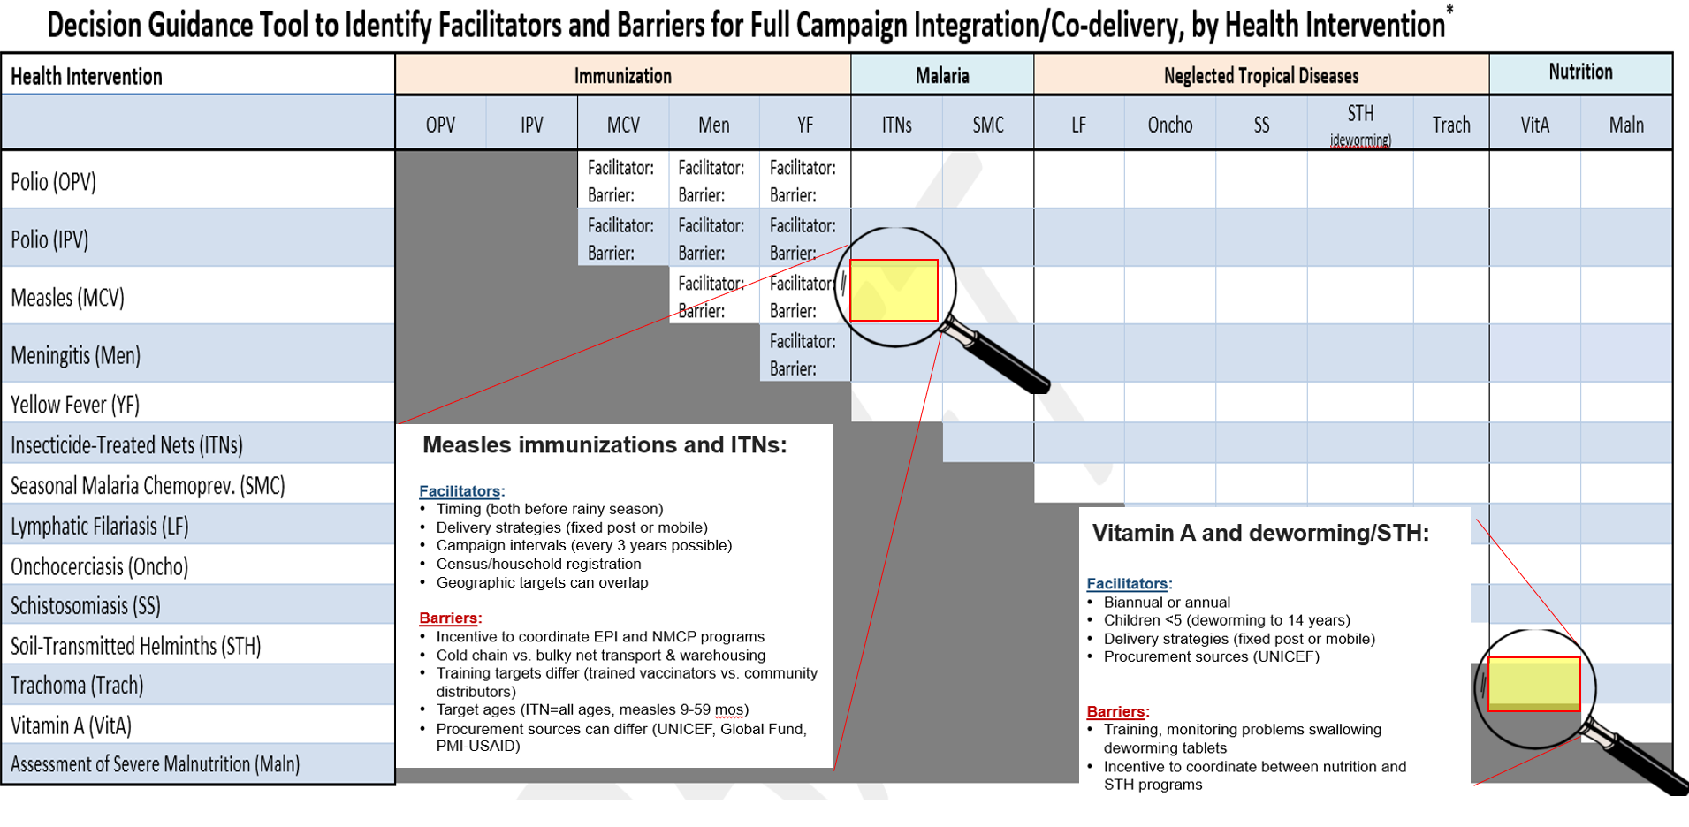
Example (Cont’d): Integrating Measles Immunization with ITNs & Integrating Vitamin A with Deworming/STH

Step 3a: Customize According to Global, Country, and/or Local Context - Assemble existing global or national policies and standards, as well as the sub-national or local contexts, to further assess whether integration is feasible and appropriate. Fill in the cells based on the suggested criteria to help this decision and planning process.

Appendix A: Worksheet for Global and Country Standards on Planning Health Campaign Integration

Country: __________ Month/Year of Planned Integration: ____________________________________ Agencies involved: ______________________________________________________________
Directions: Campaign planners discussing integration should list the campaigns below and write in the cells a summary of their thoughts or observations.

Intervention 1: ________________ Intervention 2: __________________

Criterion |  | Global Guidelines or Standards | Country's Guidelines, Policy, Standards | Local Context: Issue and Challenges
Government acceptance of integration/policy | Intervention 1
 | Intervention 2
Coordination mechanisms | Intervention 1
 | Intervention 2
Financing/funding sources | Intervention 1
 | Intervention 2
Partner/donor support | Intervention 1
 | Intervention 2
Timing/intervals | Intervention 1
 | Intervention 2
Household registration or target population census | Intervention 1
 | Intervention 2
Procurement complexity | Intervention 1
 | Intervention 2
Supply chain | Intervention 1
 | Intervention 2
Logistics/transportation | Intervention 1
 | Intervention 2
Waste Management | Intervention 1
 | Intervention 2
Acceptance & Incentives (Health workers, Community/Population, stakeholders) | Intervention 1
 | Intervention 2
Monitoring Post Campaign Adverse Events | Intervention 1
 | Intervention 2
Monitoring, Evaluation & Surveillance Capacity | Intervention 1
 | Intervention 2
Age range | Intervention 1
 | Intervention 2
Seasonality (e.g. disease peaks, transmission, weather conditions/climate) | Intervention 1
 | Intervention 2
Intervention complexity (e.g, injectable vs oral vaccine, cold chain, directly observed therapy) | Intervention 1
 | Intervention 2
Point/place of delivery (e.g. fixed post - permanent and/or temporary, mobile post, fixed or mobile post with house to house canvassing, etc.) | Intervention 1
 | Intervention 2
Duration at delivery site and district | Intervention 1
 | Intervention 2

Step 3b: Customize According to Global, Country, and/or Local Context – This tool depicts detailed technical and operational criteria and best practices involved in integration. While the table incorporates the latest global guidance and experience available when this tool was developed (see References), the list of criteria to consider is not exhaustive and should be modified to the country context and updated as needed.

Appendix B: Criteria across Health Domains and Specific Interventions for Selecting Potential Campaign Integration
(Blank cells are in need of specific information and references. Please see list of references at the end.)
Campaign Criteria | Immunizations |  | Malaria |  | Neglected Tropical Diseases |  | Nutrition
Coverage objectives per WHO  Global partner dialogue facilitation (e.g., HCE Coalition, WHO)  Global policy & operational guidance | POLIO (OPV) | High (>95%) immunization coverage two doses | INSECTICIDE-TREATED-NETS | >80% for both ITN ownership and use, targeting universal coverage, or one for ITN for every two household members regardless of age. | LYMPHATIC FILARIASIS | >65% of the entire population.³ |  | VITAMIN A | Effective coverage of >80% as threshold to improve child survival⁴ ⁵
 | POLIO (IPV) |  |  |  | ONCHOCERCIASIS | 80% therapeutic coverage (population eligible for treatment)⁶ |  | MALNUTRITION
 | MEASLES | High (>95%) immunization coverage two doses | SEASONAL-MALARIA-CHEMOPREVENTION | >95% of eligible children receive sulfadoxine-pyrimethamine + amodiaquine at monthly intervals during period of highest malaria risk. Countries may distribute sulfadoxine-pyrimethamine + amodiaquine at between two and 5 monthly intervals depending on their stratification maps and criteria used. | SCHISTOSOMIASIS | 75% school-aged children and adults in high risk communities
 | MENINGITIS | High (> 95%) vaccination coverage? |  |  | SOIL-TRANSMITTED  HELMINTHS | Global target: by 2020, treat at least 75% of children in countries endemic for soil-transmitted helminthiases
 | YELLOW FEVER | >80% with a 60-80% security threshold, to interrupt local transmission; one dose confers lifetime immunity |  |  | TRACHOMA | 80% of the entire population⁷
Seasonality of disease | POLIO (OPV) | No seasonal pattern in tropical climates; national immunization days are best during cool, dry seasons when circulation lowest and higher seroconversion occurs. | INSECTICIDE-TREATED-NETS | Peak during and after rainy season | LYMPHATIC FILARIASIS | Transmission may be seasonal (i.e., associated with rainfall), but infection and disease are chronic. |  | VITAMIN A | No seasonal pattern observed, seasonal data is not available
 | POLIO (IPV) |  |  |  | ONCHOCERCIASIS | Transmission may be seasonal⁶ (i.e., associated with rainfall), but infection and disease are chronic. |  | MALNUTRITION
 | MEASLES | After rainy season in tropical climates; late winter and early spring in temperate climates | SEASONAL-MALARIA-CHEMOPREVENTION | Peak during and after rainy season in Sahel sub-region. | SCHISTOSOMIASIS | Transmission may be seasonal (i.e., associated with rainfall), but infection and disease are chronic.
 | MENINGITIS | After the rainy season in tropical climates, the end of winter and the beginning of spring in temperate climates |  |  | SOIL-TRANSMITTED  HELMINTHS | Transmission may be seasonal (i.e., associated with rainfall), but infection and disease are chronic.
 | YELLOW FEVER | Highest risk West Africa: during end of rainy season, start of dry season (July-October); South America highest rainy season (January-May) |  |  | TRACHOMA | Transmission is more common during dry seasons.
Timing of campaign | POLIO (OPV) | 2-3 days to a week during cool, dry season | INSECTICIDE-TREATED-NETS | Ideally soon before the rainy season | LYMPHATIC FILARIASIS | Not in the rainy season. |  | VITAMIN A | Biannual distribution, Child health weeks
 | POLIO (IPV) |  |  |  | ONCHOCERCIASIS | Not in the rainy season. |  | MALNUTRITION | Not available
 | MEASLES | 4-7 days to one month, including a weekend, during low transmission season, local events & festivals, avoiding rainy seasons | SEASONAL-MALARIA-CHEMOPREVENTION | Monthly intervals during the high transmission season | SCHISTOSOMIASIS | Typically when school is in session.
 | MENINGITIS | 4-7 days to a month, including a weekend, during low transmission season, local events and festivals, avoiding rainy seasons |  |  | SOIL-TRANSMITTED  HELMINTHS | Typically when school is in session
 | YELLOW FEVER | Not available |  |  | TRACHOMA | Not in the rainy season.
Contraindications of Medicines | POLIO (OPV) |  |  |  | LYMPHATIC FILARIASIS |  |  | VITAMIN A
 | POLIO (IPV) |  | INSECTICIDE-TREATED-NETS |  | ONCHOCERCIASIS |  |  | MALNUTRITION
 | MEASLES |  |  |  | SCHISTOSOMIASIS
 | MENINGITIS |  |  |  | SOIL-TRANSMITTED  HELMINTHS
 | YELLOW FEVER |  |  |  | TRACHOMA
Target groups/ages | POLIO (OPV) | Interrupt circulation of poliovirus by immunizing every child under five years with two doses of oral polio vaccine (OPV), regardless of previous immunization status, location and social condition | INSECTICIDE-TREATED-NETS | All household members in malaria-endemic areas, regardless of age, ultimately providing one net for every two household members. | LYMPHATIC FILARIASIS | Diethylcarbamazine/albendazole to all eligible persons age 2 years;  Ivermectin/Albendazole all eligible persons >90 cm in height or >15 kg in weight³ |  | VITAMIN A | Children ages 6-59 months of age, and pregnant women.⁴ (although many countries have stopped this)
 | POLIO (IPV) |  |  |  | ONCHOCERCIASIS | All eligible persons >90 cm in height or >15 kg in weight⁸ |  | MALNUTRITION
 | MEASLES | Initial catch-up: ages 9 months-14 years; follow-up ages 9-59 months, depending on one-dose coverage, measles incidence, time since last SIA. Vaccinate all eligible children regardless of previous immunization history. | SEASONAL-MALARIA-CHEMOPREVENTION | Children ages 3-59 months; two dosage age groups: 3-11months and 12-59 months. | SCHISTOSOMIASIS | School-aged children and adults in high risk areas or professions
 | MENINGITIS | Initial Catch-up Campaign: 1-29 years;  1-5 year follow-up campaign. |  |  | SOIL-TRANSMITTED  HELMINTHS | Children ages 12 months through school age (about 12 years)
 | YELLOW FEVER | In high risk populations, all persons > 9 months, or in outbreak response, infants > 6 months and pregnant and/or breastfeeding women. |  |  | TRACHOMA | Eligible members of the community >6 months of age.
Campaign Strategies  Intervention complexity (e.g. injectable cold chain, directly observed therapy)  Place of delivery and distribution mode | POLIO (OPV) | Fixed, house-to-house or transit point teams; two rounds national immunization days, one month apart, over 3-5 years till eradication.  Mop-up campaigns conducted in areas showing poor coverage. | INSECTICIDE-TREATED-NETS | Fixed post or mobile, depending on complexity of transportation and other logistics.  Mop-up campaigns discouraged in favor of strengthened planning and monitoring. | LYMPHATIC FILARIASIS | Fixed posts (including schools) and house-to-house |  | VITAMIN A | Fixed or mobile, along with immunization and other child health services⁹  Two days for each round of Vitamin A; 1st day at fixed community site and second day door to door visit by community health volunteers for missed children
 | POLIO (IPV) |  |  |  | ONCHOCERCIASIS | Typically house-to-house |  | MALNUTRITION
 | MEASLES | Fixed post, mobile post, fixed or mobile with house-to-house canvassing, house to house immunization¹⁰ | SEASONAL-MALARIA-CHEMOPREVENTION | Mostly door-to-door distribution by community health workers; some countries use mixed models such as fixed point distribution in urban/populated settings; door-to-door in rural settings; and mobile teams to reach nomadic populations | SCHISTOSOMIASIS | Typically school-based
 | MENINGITIS |  |  |  | SOIL-TRANSMITTED  HELMINTHS | Fixed or mobile, along with immunization and other child health services
 | YELLOW FEVER | Fixed; ideal with measles campaigns for children <5 years. Preventive, catch-up (if low routine coverage and population immunity threshold for protection <70%) and reactive campaigns for outbreaks. |  |  | TRACHOMA | Typically house-to-house
Geographic targets  Geographic overlap of interventions; Check if other interventions happening/planned | POLIO (OPV) | National or subnational; promote synchronizing; national immunization days with other countries. | INSECTICIDE-TREATED-NETS | National preferred, or sub-national based on such factors as geography, local malaria epidemiology, availability of resources. | LYMPHATIC FILARIASIS | Usually sub-national  (most often district, but sub-district or village may be used) |  | VITAMIN A | National or sub-national, in areas with >1% night blindness or >20% prevalence vitamin A deficiency in young children.  All levels, national to village level
 | POLIO (IPV) |  |  |  | ONCHOCERCIASIS | Usually sub-national⁶ |  | MALNUTRITION
 | MEASLES | National preferred; phased or rolling with large territories; sub-national where high-risk areas, heterogeneity immunity, localized outbreaks, resource constraints; elimination is absence of measles for >12 months with surveillance | SEASONAL-MALARIA-CHEMOPREVENTION | Countries or areas in Sahel sub-region with highly seasonal malaria transmission. | SCHISTOSOMIASIS | Usually sub-national
 | MENINGITIS | National or localized to the meningitis belt, or according to the risk analysis |  |  | SOIL-TRANSMITTED  HELMINTHS | National or sub-national, in areas with >20% prevalence of any soil-transmitted helminth.
 | YELLOW FEVER | National or sub-national; may have to be phased over 2-3 years if total targeted population exceeds 15m and vaccine supplies not available. |  |  | TRACHOMA | Usually sub-national  (most often district)
Campaign intervals/ frequency  Duration/frequency (recurring, rotating, one time, catch up) | POLIO (OPV) | Two rounds of national immunization days per year, 4-6 weeks apart. | INSECTICIDE-TREATED-NETS | Every three years, based on median ITN survival rate in terms of physical durability and insecticide retention. | LYMPHATIC FILARIASIS | Annual |  | VITAMIN A | Two rounds (6 months apart) children ages 6-59 months
 | POLIO (IPV) |  |  |  | ONCHOCERCIASIS | Annual⁶ |  | MALNUTRITION
 | MEASLES | Initial supplementary immunization activity (SIA) to eliminate susceptible pool, follow-up SIA 2-5 years later when accumulation of susceptible preschool children approaches the size of one birth cohort; | SEASONAL-MALARIA-CHEMOPREVENTION | Every year, during highest period of malaria transmission season | SCHISTOSOMIASIS | Annual or less frequent depending on prevalence
 | MENINGITIS | Initial Catch-up Campaign;  Follow-up campaign after 2-5 years or depending on the epidemiological risk. |  |  | SOIL-TRANSMITTED  HELMINTHS | Annual if >20% prevalence, biannual if >50% prevalence
 | YELLOW FEVER | Not specified |  |  | TRACHOMA | Annual
Special populations, groups at high risk  Focus on equity (e.g. gender, rights etc.) | POLIO (OPV) | Populations in areas of recent polio circulation or low performance national immunization day rounds, urban poor settlements, remote rural populations, minority populations, mobile populations, nomads, and indigenous peoples. | INSECTICIDE-TREATED-NETS | Urban and peri-urban poor, migrants, migrant workers, refugees/IDPs, populations difficult to reach, populations with documented low ITN use despite adequate access, nomadic populations, indigenous peoples, persons in civil conflict, marginalized groups, populations with highest malaria burden or previous low campaign coverage. | LYMPHATIC FILARIASIS | Urban and per-urban settings often present challenges in achieving coverage targets  Refugees / displaced people, nomadic populations, indigenous peoples, people in civil conflict, marginalized groups. |  | VITAMIN A | Children <5 years and pregnant women in areas of high prevalence of malnutrition.
 | POLIO (IPV) |  |  |  | ONCHOCERCIASIS | Areas with co-endemic Loa require additional planning to address risk of Serious Adverse Experiences⁸  Refugees / displaced people, nomadic populations, indigenous peoples, people in civil conflict, marginalized groups |  | MALNUTRITION
 | MEASLES | Urban poor, migrants, migrant workers, refugees/internally displaced peoples, difficult to reach, nomadic populations, indigenous peoples, persons in civil conflict, marginalized groups, populations with highest measles burden. | SEASONAL-MALARIA-CHEMOPREVENTION | Children 3-59 months in areas of unstable malaria transmission and with high malaria burden. | SCHISTOSOMIASIS | Populations in high prevalence settings
 | MENINGITIS | Refugees / displaced people, nomadic populations, indigenous peoples, people in civil conflict, marginalized groups, workers, and populations in mines within the meningitis belt |  |  | SOIL-TRANSMITTED  HELMINTHS | Children <5 years in ages identified with high prevalence infection due to helminths; women of childbearing age (including pregnant women in the 2nd and 3rd trimesters and lactating women), and adults at high risk in certain occupations (e.g. tea-pickers and miners).¹¹
 | YELLOW FEVER | Urban areas, any populations with confirmed cases, border areas with countries experiencing outbreaks |  |  | TRACHOMA | Refugees / displaced people, nomadic populations, indigenous peoples, people in civil conflict, marginalized groups
Microplanning considerations | POLIO (OPV) | Similar process to ITNs. Resource estimates, cold chain and logistics, operations, supervision, recording and reporting tools, monitoring. Microplans validated at operational level. | INSECTICIDE-TREATED-NETS | Must begin preparations 9-12 months in advance. Include pre-positioning locations, budgeting, personnel needs, time for data collection, cleaning and synthesis, tools needed, training, transportation, supervision, communication needs, and evaluation. Informed by household registration of all beneficiaries, often supplemented with vouchers or coupons for net redemption at fixed sites. | LYMPHATIC FILARIASIS | Not always employed, but needed to address full coverage of all households and at-risk groups |  | VITAMIN A | Usually employed; Resource estimates, Vitamin A procurement and transportation, supervision, recording and reporting tools, community mobilization.
 | POLIO (IPV) |  |  |  | ONCHOCERCIASIS | Not always employed, but needed to address full coverage of all households and at-risk groups |  | MALNUTRITION
 | MEASLES | Must begin preparations 9-12 months before supplementary immunization activity (SIA). Similar process to ITNs: estimating target population with census, community registers, line list from women’s groups and leaders, previous polio or measles SIA data, number of children vaccinated with BCG (Bacillus Calmette–Guérin vaccine is a vaccine primarily used against tuberculosis) or first dose DTPCV Diphtheria, Tetanus, Pertussis containing vaccine; Joint External Evaluation | SEASONAL-MALARIA-CHEMOPREVENTION | Must place orders at least 8 months in advance of campaigns. Operational preparations starting at least 6 months in advance of the start of the campaign, including personnel needs, procurement of materials need by community health workers and other supplies, data collection tools and planning, pharmacovigilance, training personnel, transportation, supervision, communication needs, and post-campaign coverage surveys. | SCHISTOSOMIASIS | Focused on schools.
 | MENINGITIS | Preparations should start 9-12 months before national immunization days. Process relates to the stages: count or estimate of the target population with census, community registers, list of community agents, community relays, community leaders previous data on polio or measles supplementary immunization activity, number of children vaccinated with BCG or Penta 1 (first dose).  Monitor the level of preparations for the online Health District campaigns as practiced with the polio national immunization days. |  |  | SOIL-TRANSMITTED  HELMINTHS | TBD
 | YELLOW FEVER |  |  |  | TRACHOMA
Estimating Target Populations | POLIO (OPV) | Target populations can be based on the administrative population, the number of children vaccinated during previous supplementary immunization activities, and/or quality micro-planning if time allows. ¹² | INSECTICIDE-TREATED-NETS |  | LYMPHATIC FILARIASIS | Usually based on official census projections minus 10–15%, depending on estimates of the ineligible population, or calculated by house-to-house registration done directly before  the mass drug administration ³ |  | VITAMIN A | Estimation by Health Management Information System; target 6-59 month and postpartum mothers
 | POLIO (IPV) |  |  |  | ONCHOCERCIASIS | Census estimates or households registers or school enrollment estimates depending on neglected tropical disease. |  | MALNUTRITION | Based on the prevalence of malnutrition provided by population based national level surveys; Demographic and Health Surveys.
 | MEASLES |  | SEASONAL-MALARIA-CHEMOPREVENTION | Household registration | SCHISTOSOMIASIS
 | MENINGITIS |  |  |  | SOIL-TRANSMITTED  HELMINTHS
 | YELLOW FEVER |  |  |  | TRACHOMA
Methods of estimating supply requirements | POLIO (OPV) | OPV wastage in 20-dose vials during supplementary immunization activity: 15%; 1.2 wastage factor; mOPV2 (Monovalent type 2 oral polio vaccine) supply = Target population x 1.15¹² | INSECTICIDE-TREATED-NETS | For ITN procurement: calculate 1.8 nets per person, accounting for use of each net by 2 persons and adjusting for odd numbers of household occupants. Countries now allow for wastage factor. | LYMPHATIC FILARIASIS | Estimates generated automatically through WHO Joint Application Package¹³ |  | VITAMIN A | If no population data denominators separated by age group, the proportion of children who are 6 – 11 months old is generally estimated to be 0.111 and the proportion of children who are 12 – 59 months old is generally estimated to be 0.889.  Based on the target population provided by Health Management Information System
 | POLIO (IPV) |  |  |  | ONCHOCERCIASIS | Estimates generated automatically through WHO Joint Application Package¹³ |  | MALNUTRITION
 | MEASLES | Vaccine: based on target population and vaccine wastage rates; cold chain & other supplies estimated by varying methods. | SEASONAL-MALARIA-CHEMOPREVENTION | For calculating the total number of sulfadoxine-pyrimethamine + amodiaquine blister-packs needed for procurement: Consider the total number of children 3-59 months living in the seasonal areas of high transmission, and multiply by the number of monthly intervals. Consider adding a buffer stock of 5%-10% depending on the country context and budget to accommodate for any inaccuracies of original planning data or population movement. | SCHISTOSOMIASIS | Estimates generated automatically through WHO Joint Application Package
 | MENINGITIS | Vaccine: depending on target population and vaccine wastage rates; cold chain and other supplies estimated by different methods. |  |  | SOIL-TRANSMITTED  HELMINTHS | Estimates generated automatically through WHO Joint Application Package¹³
 | YELLOW FEVER |  |  |  | TRACHOMA | Estimates generated through the International Trachoma Initiative application process
Communications/ Social and Behavior Change  Communication (e.g. to address rumors, hesitancy)  Focus on equity (e.g. gender, rights etc.)  Values (Active community participation throughout phases  Partial integration (census data, social mobilization, education, messaging) | POLIO (OPV) | Identify target age for immunization; prepare to manage issues such as negative publicity, rumors, refusals | INSECTICIDE-TREATED-NETS | Messages for each stage of campaign (pre, during and post) to instruct on hanging, when to use, care and repair, washing, disposition of older nets | LYMPHATIC FILARIASIS | Messages on purpose, benefits and side effects associated with mass drug administration. |  | VITAMIN A | PSA through community radio stations and place, TV announcements, push messaging, social media, loudspeaker announcements, mothers group meetings
 | POLIO (IPV) |  |  |  | ONCHOCERCIASIS | Messages on purpose, benefits and side effects associated with mass drug administration. |  | MALNUTRITION
 | MEASLES | Identify target age for immunization; prepare to manage issues such as negative publicity, rumors, Adverse Event Following Immunization | SEASONAL-MALARIA-CHEMOPREVENTION | Messages for each stage of campaign (pre, during and post) to communicate the dates of the campaign, eligibility to receive sulfadoxine-pyrimethamine + amodiaquine , remind caregivers to take daily doses 2 and 3, importance of going to health center in case of side effects, and on general malaria prevention and treatment. | SCHISTOSOMIASIS | School and community-based education on causes and benefits of mass drug administration.
 | MENINGITIS | Identify the target age for vaccination; prepare to deal with issues such as negative publicity, rumors, Adverse Event Following Immunization |  |  | SOIL-TRANSMITTED  HELMINTHS | Messaging on target ages; need train volunteers to communicate in handling children who cannot swallow pill, and to crush pill for children <3 years.¹¹
 | YELLOW FEVER | Risk communication, target mobilization to highest-risk populations |  |  | TRACHOMA | Messages on purpose, benefits and side effects associated with mass drug administration and on elements of the SAFE (Surgery i.e. in-turned eyelashes, Antibiotics, Facial Cleanliness, Environmental improvement) strategy.
Procurement and timeframe considerations  Financing—Government & donors; Incentives for integration  Discussion and agreement with partners (advantages of integration and pooling of resources) | POLIO (OPV) | Vaccines all shipped by air, require 3-5 months; up to 4 weeks for delivery of immunization equipment by sea. | INSECTICIDE-TREATED-NETS | Global Fund: minimum 6-7 months between order and delivery  President’s Malaria Initiative: 10 months from request to delivery in country (as of January 2018)  UNICEF: 5-8 months minimum to place order, receive funds by UNICEF, shipping and freight lead time, and arrival and positioning in country | LYMPHATIC FILARIASIS | Place order 9-12 months before mass drug administration |  | VITAMIN A
 | POLIO (IPV) |  |  |  | ONCHOCERCIASIS | Place order 9-12 months before mass drug administration |  | MALNUTRITION
 | MEASLES | Place order 9-12 months before campaign; comprehensive multi-year strategic plans. | SEASONAL-MALARIA-CHEMOPREVENTION | Global Fund: Minimum 8 months lead time.  PMI: plan for minimum 12-month lead time given limited sulfadoxine-pyrimethamine + amodiaquine production capacity | SCHISTOSOMIASIS | Place order 9-12 months before mass drug administration
 | MENINGITIS | Place order 9-12 months before campaign. |  |  | SOIL-TRANSMITTED  HELMINTHS | Place order 9-12 months before mass drug administration
 | YELLOW FEVER | Fluid: limited production capacity constrains supplies, UNICEF prioritizes campaigns. International Coordinating Group for Vaccine Provision manages a GAVI-supported emergency stockpile. |  |  | TRACHOMA | Place order 12 months before mass drug administration
Procurement Sources | POLIO (OPV) | UNICEF Supply Division | INSECTICIDE-TREATED-NETS | Global Fund, President’s Malaria Initiative and others directly from net manufacturers; UNICEF Supply Division | LYMPHATIC FILARIASIS | WHO with possible review by the Mectizan Donation Program |  | VITAMIN A | UNICEF Supply Division,
 | POLIO (IPV) |  |  |  | ONCHOCERCIASIS | WHO - reviewed by Mectizan Donation Program⁶ |  | MALNUTRITION | UNICEF Supply Division
 | MEASLES | UNICEF Supply Division; UNICEF, PAHO Revolving Fund, Gavi Roadmap, healthy market framework, MI4A | SEASONAL-MALARIA-CHEMOPREVENTION | Global Fund: Pooled Procurement Mechanism directly from supplier (Guilin)  President’s Malaria Initiative: TBD | SCHISTOSOMIASIS | WHO
 | MENINGITIS | UNICEF Supply Division |  |  | SOIL-TRANSMITTED  HELMINTHS | UNICEF Supply Division¹⁴
 | YELLOW FEVER | UNICEF Supply Division |  |  | TRACHOMA | International Trachoma Initiative
Training  Coordination mechanisms, including public health workforce  Health worker acceptance of all individual interventions & of integration  Community capacity to ensure effective integration (e.g., training) | POLIO (OPV) | Vaccinators, supervisors, monitors, volunteers, district-level program managers, logisticians, communication focal persons. | INSECTICIDE-TREATED-NETS | Supervisors, monitors, health workers, volunteers, district-level program managers, logisticians, communication focal persons. | LYMPHATIC FILARIASIS | Community health workers, supervisors, monitors, health workers, volunteers, district-level program managers, logisticians, communication focal persons |  | VITAMIN A | Supervisors, monitors, health workers, volunteers, district-level program managers, logisticians, communication focal persons.  Health workers, Community Health Volunteers
 | POLIO (IPV) |  |  |  | ONCHOCERCIASIS | Community health workers, supervisors, monitors, health workers, volunteers, district-level program managers, logisticians, communication focal persons |  | MALNUTRITION | Health workers, Community Health Volunteers.
 | MEASLES | Vaccinators, supervisors, monitors, volunteers, district-level program managers, logisticians, communication focal persons. | SEASONAL-MALARIA-CHEMOPREVENTION | Community health workers, supervisors, monitors, health workers, volunteers, district-level program managers, pharmacovigilance point persons, logisticians, communication focal persons. | SCHISTOSOMIASIS | Teachers, supervisors, monitors, health workers, volunteers, district-level program managers, logisticians, communication focal persons.
 | MENINGITIS | Vaccinators, supervisors, monitors, volunteers, district program managers, logisticians, communication focal persons. |  |  | SOIL-TRANSMITTED  HELMINTHS | Teachers, supervisors, monitors, health workers, volunteers, district-level program managers, logisticians, communication focal persons.
 | YELLOW FEVER | Vaccinators, supervisors, monitors, volunteers, district-level program managers, logisticians, communication focal persons. |  |  | TRACHOMA | Community health workers, supervisors, monitors, health workers, volunteers, district-level program managers, logisticians, communication focal persons
Supply, supply chain, transportation, and logistics  Operational complexity (procurement, supply chain, logistics, communications, waste management) | POLIO (OPV) | Cold chain maintenance and supplies, waste management; It is not recommended to implement Multi-dose vial policy in mOPV2 (Monovalent type 2 oral polio vaccine) campaigns¹² | INSECTICIDE-TREATED-NETS | Bulkiness of ITNs, warehousing challenges; timeliness of ITN delivery and positioning in field given multiple procurement sources and methods | LYMPHATIC FILARIASIS | Managed through national pharmacy with support from partners |  | VITAMIN A | Manage through logistic management division of Ministry of Health and Provincial Health Directorate
 | POLIO (IPV) |  |  |  | ONCHOCERCIASIS | Managed through Mectizan Donation Program, national pharmacy with support from partners⁶ |  | MALNUTRITION | Manage through logistic management division of Ministry of Health and Population and Provincial Health Directorate
 | MEASLES | Cold chain maintenance, immunization supplies, waste management | SEASONAL-MALARIA-CHEMOPREVENTION | Community health worker system must be highly functional in implementation area for success; ensuring availability of monthly sulfadoxine-pyrimethamine + amodiaquine supplies critical. Timely delivery of supplies critical to match malaria season and 28-day interval between monthly administration of doses. Drug supply delivery must occur during logistically challenging rainy season. | SCHISTOSOMIASIS | Managed through national pharmacy with support from partners
 | MENINGITIS | Cold chain maintenance, immunization supplies, waste management |  |  | SOIL-TRANSMITTED  HELMINTHS | Must administer medication before measles immunization in campaign setting.
 | YELLOW FEVER | Cold chain maintenance, immunization supplies, lyophilized vaccine—reconstitution with diluent. Limited vaccine supply (demand increase, production problems), limited to 15m people per year for preventive campaigns; challenging in urban areas. Need distribute immunization cards. |  |  | TRACHOMA | Managed through International Trachoma Initiative with support from governments and partners.
Monitoring and supervision  (Monitoring Post Campaign Adverse Events, capacity for & commitment to monitoring/surveillance) | POLIO (OPV) | Independent monitoring with Lot quality assurance sampling or other established method; GIS mapping to locate catchment areas. Cold chain and Adverse Event Following Immunization monitoring required. | INSECTICIDE-TREATED-NETS | Promote engagement of both supervisors and independent monitors, depending on population served and number of campaign personnel overseen | LYMPHATIC FILARIASIS | Need monitor drug administration for difficulties swallowing  Supervision of community health workers managed through health system |  | VITAMIN A | Supervision of community health workers managed through health system, Bi-annual review meetings with health service providers
 | POLIO (IPV) |  |  |  | ONCHOCERCIASIS | Supervision of community health workers managed through health system |  | MALNUTRITION
 | MEASLES | SIA Readiness Assessment Tool; pre-SIA supervision & monitoring; checklists; rapid convenience monitoring to find & vaccinate any unreached children. Cold chain and and Adverse Event Following Immunization monitoring required; Measles and Rubella Strategic Framework 2021-2030/IA2030¹⁵ | SEASONAL-MALARIA-CHEMOPREVENTION | Intense supervision needed given dosage requirements and 28-day timing interval, specific age range, importance of not giving SMC for children with fever at the time, and observing child for 30 minutes in case of vomiting. Especially important for first cycle and first month to identify and address problems. | SCHISTOSOMIASIS | Need monitor drug administration for difficulties swallowing
 | MENINGITIS | Adverse Event Following Immunizations |  |  | SOIL-TRANSMITTED  HELMINTHS | Need monitor drug administration for difficulties swallowing¹¹
 | YELLOW FEVER | Monitor for vaccine availability, injection safety, immunization card availability, cold chain, Adverse Event Following Immunization and reporting. Strict border control. |  |  | TRACHOMA | Supervision of community health workers managed through health system
Data collection | POLIO (OPV) | Tally sheets divided as 0-11 and 12-59 months; other recording strategies similar to measles campaigns. | INSECTICIDE-TREATED-NETS | Careful planning needed for data collection and analysis in integrated versus stand-alone campaigns. GPS and electronic databases used more widely but need to reconcile multiple collection modalities implemented within countries. | LYMPHATIC FILARIASIS | Drug treatment registers or tally sheets.³ |  | VITAMIN A | Vitamin A register filled by Female Community Health Volunteers in campaign and reported to higher level as per Health Management Information System reporting system
 | POLIO (IPV) |  |  |  | ONCHOCERCIASIS | Drug treatment registers or tally sheets.¹³ |  | MALNUTRITION | Nutrition Register, Integrated Management of Acute Malnutrition register, Primary Health Care Outreach register, Female Community Health Volunteers register
 | MEASLES | Review immunization cards/home-based records; tally sheets divided as 9-11 months, 1-4 years, 5-14 years; daily review meetings; daily reporting forms; data electronic input aggregated at district, provincial, national levels; testing and use of available and reliable technology encouraged, such as GPS to monitor geographic coverage. | SEASONAL-MALARIA-CHEMOPREVENTION | Simple registers and reporting forms must be developed for community health workers to complete; every child is provided with a SMC child card used to record monthly doses; quality control essential through supervision and monitoring. More and more countries are moving to electronic data collection forms. | SCHISTOSOMIASIS | Drug treatment registers or tally sheets.
 | MENINGITIS | Epidemic Meningitis A Supplementary Immunization Activity Readiness Assessment Tool; supervision and monitoring prior to the supplementary immunization activity; checklists; rapid convenience monitoring to find and immunize unaffected children. Independent monitoring with Lot Quality Assurance Sampling, Cold chain, and monitoring of adverse events after vaccination are important; Adverse Event Following Immunization notification and investigation forms  Monitor the level of preparations for online health district campaigns as practiced with polio national immunization days. Need to monitor administration of medication for swallowing difficulties |  |  | SOIL-TRANSMITTED  HELMINTHS | Drug treatment registers or tally sheets.
 | YELLOW FEVER | No information. |  |  | TRACHOMA | Drug treatment registers or tally sheets.
Evaluation  Linkage to global/regional goals & local/regional priorities  Structural barriers | POLIO (OPV) | Post national immunization days coverage surveys not recommended; focus on Acute Flaccid Paralysis surveillance for children <15 years | INSECTICIDE-TREATED-NETS | Campaign quality: qualitative and/or quantitative process review, or post-campaign review meetings.  Outcomes (coverage, access, use): generally rely on existing schedule of population-based surveys such as Demographic Health Survey, Malaria Indicators Survey or Multiple Indicator Cluster Survey; if those are scheduled far in future, stand-alone post-campaign surveys conducted in rainy season per country guidance | LYMPHATIC FILARIASIS | Periodic coverage surveys and impact assessments.³ |  | VITAMIN A | Population-based coverage surveys (e.g., Demographic and Health Surveys, Multiple Indicator Cluster Survey
 | POLIO (IPV) |  |  |  | ONCHOCERCIASIS | Impact surveys carried out after many years of mass drug administration |  | MALNUTRITION | National level survey: Demographic and Health Surveys, Multiple Indicator Cluster Survey, Medical nutritional supplements
 | MEASLES | Post-supplementary immunization activity independent monitoring using rapid coverage monitoring to find unvaccinated children and target mop-up activities immediately post-campaign; coverage surveys soon after SIA if population-based survey (Demographic Health Survey , Ministry of Industry, Commerce, and Supplies, stand-along Expanded Program of Immunization survey) not done for a few years and one not planned for few years | SEASONAL-MALARIA-CHEMOPREVENTION | No established method for monitoring programmatic effectiveness as of 2013 guidance. Potential random sampling of children for parasitemia during second or third course to determine “breakthrough infections” after first course. Post-campaign coverage surveys to evaluate for example the coverage per monthly cycle, adherence to home doses 2 & 3, treatment of older children, caregiver SMC knowledge, and intervals between cycles | SCHISTOSOMIASIS | Impact surveys after 3-5 years of mass drug administration
 | MENINGITIS |  |  |  | SOIL-TRANSMITTED  HELMINTHS | Population-based coverage surveys e.g., Demographic and Health Surveys, Multiple Indicator Cluster Survey  Impact surveys after 3-5 years of mass drug administration
 | YELLOW FEVER |  |  |  | TRACHOMA | Impact surveys after 3-5 years of mass drug administration

Appendix C: Key Categories of Considerations for Campaign Integration

FEASIBILITY
Operational and financial viability of integrating the interventions.

ACCEPTABILITY
Integrated interventions are acceptable to the community and health workers.
ACCOUNTABILITY
“The obligation to report or give account of one’s actions, for example, to a governing authority through scrutiny, contract, management and regulation or to an electorate” (WHO and UNICEF 2020). In the context of integrated campaigns, it is having clearly defined roles, responsibilities, and monitoring and evaluation strategies to assess outcomes pre- and post-co-delivery/collaboration (e.g., coverage and utilization rates, disease occurrence, quality, acceptability of services).

CONTEXT
The circumstances that influence the co-delivery/collaboration decision, such as geographical setting (rural or urban areas), target population of the interventions, political will to promote co-delivery/collaboration among different interventions, existing health care structures for the delivery of interventions; monitoring responsibilities for each intervention, and availability and ability of health workers to work on multiple interventions at the same time.

COMPATIBILITY
Alignment between different intervention components and shared campaign characteristics, such as overlaps in the target population, type of intervention, seasonality of the disease, timing and frequency of service delivery; procurement, supply chain, and logistics mechanisms and timing, behavior change requirements and skill level and training of health workers.

EQUITY
“The absence of systematic or potentially remediable differences in health status, access to health care and health-enhancing environments, and treatment in one or more aspects of health across populations or population groups defined socially, economically, demographically or geographically within and across countries” (WHO and UNICEF 2020). Integrated campaigns should not reduce service access among vulnerable groups, and should provide high-quality interventions uniformly and in a fair and impartial manner to all target populations including underserved groups.

Abbreviations/Acronyms

AEFI | Adverse Event Following Immunization |  | MIS | Malaria Indicators Survey
AFP | Acute Flaccid Paralysis |  | MMRV | Measles, Mumps, Rubella, Varicella
ALB | Albendazole |  | MoH | Ministry of Health
BCG | Bacillus Calmette–Guérin vaccine primarily used against tuberculosis |  | mOPV2 | Monovalent Type 2 Oral Polio Vaccine
CDC | U.S. Centers for Disease Control and Prevention |  | MOV | Missed Opportunities for Vaccination
CHD | Child Health Day |  | NID | National Immunization Day
cMYP | Comprehensive Multi-Year Strategic Plans |  | ONCHO | Onchocerciasis
DEC | Diethylcarbamazine (citrate) |  | OPV | Oral Polio Vaccine
DOT | Directly Observed Therapy |  | PECS | Post Event Coverage Survey
DHS | Demographic and Health Surveys |  | POS | Pediatric Oral Suspension
GAVA | Global Alliance for Vitamin A |  | PZQ | Praziquantel
GPS | Global Positioning System |  | RI | Routine Immunization
HCD | Human Centered Design |  | SAE | Serious Adverse Experience
HCE | Health Campaign Effectiveness |  | SAGE | Strategic Advisory Group of Experts
HCW | Healthcare Worker |  | SC | Subcutaneous
HH | Household |  | SCH | Schistosomiasis
HKI | Hellen Keller International |  | SIA | Supplementary Immunization Activity
HMIS | Health Management Information System |  | SMART | Specific, Measurable, Achievable, Relevant, and Timebound
HPV | Human Papillomavirus |  | SMS | Short Messages Services (text messaging)
IDP | Internally Displaced Peoples |  | SP/AQ | Sulfadoxine-Pyrimethamine + Amodiaquine
IPV | Inactivated Polio Vaccine |  | STH | Soil-transmitted Helminthiasis
IU | International Units |  | TIP | Tailoring Immunization Programs
IVM | Ivermectin |  | Trach | Trachoma
JEE | Joint External Evaluation |  | UNICEF | United Nations Children’s Fund
LF | Lymphatic filariasis |  | VAS | Vitamin A Supplementation
LMIS | Logistics Management Information System |  | WHO | World Health Organization
LQAS | Lot Quality Assurance Sampling |  | WHO JAP | World Health Organization Joint Application Package
MDA | Mass Drug Administration |  | WMF | Wastage Multiplication Factor
MDVP | Multi Dose Vial Policy |  | YF | Yellow Fever
MI4A | Market Information for Access to Vaccines
MICS | Multiple Indicator Cluster Survey

Definitions of Criteria (illustrative)
Adverse reaction (to a drug) | Noxious and unintended reaction, which occurs at doses normally used in humans for the prophylaxis, diagnosis or treatment of disease, or for the modification of physiological function.¹¹
Campaign (health) | Time-bound, intermittent activities deployed to address specific epidemiologic challenges, expediently fill delivery gaps, or provide surge coverage for health interventions.
Catch-up SIA | One-time SIA, usually nation-wide, to vaccinate the main target population responsible for disease transmission in order to rapidly reduce the number of susceptible individuals.
Catch-Up Vaccination | “Refers to vaccinating an individual with any vaccines missed per the national immunization schedule. It can be delivered through regular routine immunization service delivery (fixed, outreach, mobile, school), periodic intensification of routine immunization (PIRI) activities, or any other strategy to ensure individuals have the opportunity to receive routine immunizations for which they are eligible. This is distinct from the concept of ‘catch-up SIAs’ that are one-time campaigns to vaccinate the main target population responsible for disease transmission in order to rapidly reduce the number of susceptible individuals, other ‘catch-up campaigns’ that sometimes accompany new vaccine introductions, or from the strategy of ‘catch-up, keep-up, follow-up, speed-up’ used for measles elimination in the Region of the Americas” ¹⁶
Community Acceptance | Consider factors that are convenient for the community. Collaborate with local community groups to determine the best dates, times, and locations to promote ownership. Consider community activities/celebrations and local events such as religious festivals, key agricultural activities, and timing of political activities. Adapt the TIP and HCD approaches to design more people-centered strategies to improve vaccine delivery and uptake.
Coverage | A proportion (%) that reflects the number of people receiving (an) intervention(s) divided by the total number of people eligible to receive the intervention(s).
Denominator | The total number of a population for an indicator.
Disaggregation (of data) | Analysis of data by different sub-groups, for example, analysis of data by smaller administrative units or by different age groups.
District | For the purpose of this guide, “district” refers to a defined sub-national administrative area.
Drug coverage | Proportion of individuals, expressed as a percentage, in a targeted population who swallowed a drug, or a combination of drugs.³
Effectiveness | The ability of a campaign to achieve specific objectives related to coverage, equity, efficiency and impact.
Equity | Providing high-quality interventions uniformly and in a fair and impartial manner to all target populations including underserved groups.
Ethical Use | Morally right, rooted in equality, and aiming to prioritize good and minimize harm.
Fixed permanent vaccination posts | Posts located at permanent health facilities and community health posts as a part of the fixed vaccination posts SIA strategy for the entire duration of the SIA.
Fixed post with house-to-house canvassing | SIA strategy with added social mobilization element, which involves a trained volunteer/ community mobilizer ("canvasser") encouraging the population to come to the vaccination post.
Fixed temporary vaccination posts | Posts that may be set up at schools, churches, mosques, local administrators’ offices, for the time estimated to complete the vaccination of the targeted population of that area (may be less than the duration of the SIA).
Fixed vaccination posts | Effective SIA strategy in settings where there is high demand for vaccination, social mobilization is strong and house-to-house visits are not needed; includes permanent and temporary vaccination posts.
Full integration | Full integration involves coordinating most or all campaign components (e.g., microplanning, registration, logistics, implementation, evaluation) to allow simultaneous or co-delivery of two or more health interventions at the point of service delivery.
House-to-house vaccination | SIA strategy recommended mainly as a mop-up strategy in areas where there is prior evidence of refusal of vaccination.
Ineligible population | Group of individuals not qualified or entitled to receive anthelminthic treatment in preventive chemotherapy interventions. Ineligibility is usually determined by exclusion criteria based on drug safety. ³
Mass drug administration (MDA) | A modality of preventive chemotherapy in which anthelminthic medicines are administered to the entire population of an area (e.g. state, region, province, district, sub-district, village) at regular intervals, irrespective of the individual infection status.³
Mobile vaccination posts | Posts required at distant villages and rural settlements with very small and/or disperse populations, set up for the time needed to complete the task (usually less than one day).
Partial Integration | Partial integration involves collaboration or sharing of specific campaign components between vertical health programs to improve efficiency and effectiveness of multiple campaigns, but without co-delivery of interventions at the same service delivery points.
People-centered care | An approach to care that consciously adopts individuals’, caretakers’, families’ and communities’ perspectives as participants in, and beneficiaries of, trusted health systems that are organized around the comprehensive needs of people rather than individual diseases, and respects social preferences. People-centered care also requires that patients have the education and support they need to make decisions and participate in their own care and that caretakers are able to attain maximal function within a supportive working environment. People-centered care is broader than patient and person-centered care, encompassing not only clinical encounters, but also including attention to the health of people in their communities and their crucial role in shaping health policy and health services.¹⁷
Place of Delivery and Distribution Mode | Options include fixed post (permanent and/or temporary), mobile post, fixed or mobile post with house to house canvassing, etc.
Preferences of beneficiaries | Consider community activities/celebrations and local events such as religious festivals, key agricultural activities, and timing of political activities.
Seasonality | Consider disease peaks, transmission, weather conditions/climate (rainy seasons, winters with heavy snowfalls), ¹⁸
Social mobilization | A group of broad-scale activities to engage with all segments of society aiming to disseminate information and ensure appropriate awareness.

References (draft)
1. Lavery J V. Wicked problems’, community engagement and the need for an implementation science for research ethics. J Med Ethics. 2018;44(3):163-164. doi:10.1136/medethics-2016-103573
2. Lavery J V. Building an evidence base for stakeholder engagement. Science. 2018;361(6402):554-556. doi:10.1126/science.aat8429
3. WHO. World Health Organization Global Programme To Eliminate Lymphatic Filariasis.; 2010. Accessed April 23, 2020. https://apps.who.int/iris/bitstream/handle/10665/44473/9789241500722_eng.pdf?sequence=1
4. Dalmiya N, Greig A, Knowles J. GAVA - Monitoring of Vitamin A Supplementation - A Guide for National Managers.; 2017. http://www.gava.org/content/user_files/2017/08/GAVA-district-vas-monitoring-guide-1.pdf
5. WHO. Vitamin A Supplementation in Infants and Children 6-59 Months of Age II Vitamin A Supplementation in Infants and Children 6-59 Months of Age.; 2011. Accessed April 23, 2020. https://apps.who.int/iris/bitstream/handle/10665/44664/9789241501767_eng.pdf?sequence=1
6. WHO. Guidelines for stopping mass drug administration and verifying elimination of human onchocerciasis: Criteria and Procedures. World Health Organization WHO/HTM/NTD/PCT Geneva, Switz. 2016;14(3):62-75. Accessed April 23, 2020. https://apps.who.int/iris/bitstream/handle/10665/204180/9789241510011_eng.pdf
7. International Coalition for Trachoma Control (ICTC). Micro-planning for effective Zithromax ® Mass Drug Administration. Published online 2015.
8. Etya D. Vision 2020 : Update on Onchocerciasis. Community Eye Heal. 2010;14(38):19-21.
9. Dalmiya N, Greig A, Knowles J. GAVA - MONITORING OF VITAMIN A - District Guide.
10. United Nations Children’s Fund. UNICEF Immunization Roadmap 2018–2030. UNICEF. Published online 2018:1-48.
11. Crompton DWT (David WT, World Health Organization. Preventive Chemotherapy in Human Helminthiasis : Coordinated Use of Anthelminthic Drugs in Control Interventions : A Manual for Health Professionals and Programme Managers. World Health Organization; 2006.
12. mOPV2- Technical Guidance (Dated: 9 May 2020) 1. 2020;1(May):1-2.
13. WHO. Joint Request for Selected Preventive Chemotherapy Medicines and Joint Reporting Form 16:50:16.; 2013. http://www.who.int/neglected_diseases/en
14. WHO. Preventative in Human Helminthiasis Chemotherapy.; 2006. Accessed April 23, 2020. https://apps.who.int/iris/bitstream/handle/10665/43545/9241547103_eng.pdf?sequence=1
15. WHO. Immunization Agenda 2030. 2019;(August):1-24. https://www.who.int/immunization/ia2030_Draft_One_English.pdf?ua=1
16. Measles & Rubella Initiative. Measles and Rubella Strategic Framework 2021 - 2030. Published online 2021.
17. Vaccine acronyms and abbreviations. (2016, May 31). Retrieved March 20, 2021, from https://www.cdc.gov/vaccines/terms/vacc-abbrev.html
18. World Health Organization (WHO). Framework on integrated, people-centered health services: Report by the Secretariat. World Health Assem. 2016;(A69/39):1-12. doi:10.1111/igs.13866
19. WHO. Planning and Implementing High-Quality Supplementary Immunization Activities for Injectable Vaccines Using an Example of Measles and Rubella Vaccines Field Guide.; 2016. Accessed April 23, 2020. https://www.who.int/immunization/diseases/measles/SIA-Field-Guide.pdf

