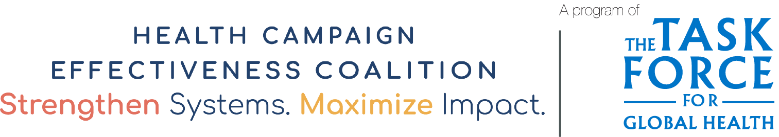
Survey - Satisfaction with Integrated Campaign
The following satisfaction survey collects feedback from individuals who received services during an integrated neglected tropical disease campaign. You can use this template as a starting point for your own integrated campaign survey.

Informed consent
I am …………………………………, a member of [program / organization name]. This study aims to [explore ways to integrate two or more health campaigns to maximise benefits to the health system.]
You are requested to share your experiences about receiving services through campaigns in [LOCATION]. Kindly answer the questions which I am going to ask you regarding the last health campaign conducted in your district.
The interview may take 15 - 20 minutes. The information you share will be confidential and will be used only for preparing the study report and related publications. Your views will be utilized to design the study report but your name will not be mentioned and your views will also not be ascribed to you specifically anywhere in the report.
Your participation is your decision and will not affect your receipt of services. If you choose to take part, your inputs will be valuable in helping us find ways for improving the efficiency and effectiveness of providing these services simultaneously. You are free to leave the interview at any time without consequences, should you wish to do so.
Can we proceed ? Yes…… No……
Do you have any queries or concerns which you want me to address now Yes……No…..
If you have any further queries or concerns, you are free to contact:
[CONTACT INFORMATION OF STUDY LEAD]

1. Interview details
1.1 Interviewer ID : |  | 1.2 Date:
2. Background information of respondents
2.1 District: | 2.2. Block: |  | 2.3 Village:
2.4 Number of family members: | 2.5 Gender:  Male……… Female……… |  | 2.6 Age:
2.7 Beneficiary age: | Beneficiary Gender:  Male……… Female…….. |  | Relationship to beneficiary:
3. Satisfaction questions
- Did you receive information about the National Deworming Day and lymphatic filariasis (LF) treatment in your locality in advance ( at least 2 days before the campaign day)? |  |  |  | 1=Yes 2 = No  If No, skip to 3.3
- Services provided during the campaign?  - Vaccination  - Deworming  - LF drug therapy  - Other, mention |  |  |  | Circle all that apply
- How did you receive information regarding the campaign?  - Through village leaders  - Through neighbours/relatives/friends  - Through community health workers  - Notices/pamphlets  - Any other, please mention |  |  |  | Circle all that apply
- Where did you receive the service?  - Health center  - Community center  - Local school  - Administrative office  - Other, specify |  |  |  | Circle all that apply
- Did you think this service was important to address a significant problem faced by the community?  - Highly necessary  - Necessary  - Neither necessary nor not necessary  - Unnecessary  - Highly unnecessary |  |  |  | Circle one
- How far away was the venue where you received service from your home or workplace?  - Very far  - Far  - Neither far nor near  - Near  - Very near |  |  |  | Circle one
- How satisfied were you about the facilities at the venue?  - Very satisfied  - Satisfied  - Neither satisfied nor dissatisfied  - Dissatisfied  - Very dissatisfied |  |  |  | Circle one
- How satisfied were you regarding the time you had to wait for the service?  - Very satisfied  - Satisfied  - Neither satisfied nor dissatisfied  - Dissatisfied  - Very dissatisfied |  |  |  | Circle one
- How satisfied were you regarding the service that was provided to you?  - Very satisfied  - Satisfied  - Neither satisfied nor dissatisfied  - Dissatisfied  - Very dissatisfied |  |  |  | Circle one
3.10 How satisfied were you regarding the behavior of staff at the facility?  - Very satisfied  - Satisfied  - Neither satisfied nor dissatisfied  - Dissatisfied  - Very dissatisfied |  |  |  | Circle one
- How satisfied were you regarding the follow up care that was provided to you?  - Very satisfied  - Satisfied  - Neither satisfied nor dissatisfied  - Dissatisfied  - Very dissatisfied |  |  |  | Circle one
- What did you appreciate most in the service provided ?  - Well informed  - Prompt care  - Quality care  - Well organized  - Other (specify):______________________ |  |  |  | Circle all that apply
- Are there any areas for improvement ?  - If yes, please mention  …………………………………………………………………………………………………….  ……………………………………………………………………………………………………. |  |  |  | 1=Yes 2=No
  - Any other comments or feedback?

Acknowledgements

Adapted with gratitude from a document developed by IIHMR to guide to assess stakeholder perceptions and beneficiary satisfaction with existing campaign elements that are integrated for neglected topical diseases and other health interventions in Uttar Pradesh, India.

IIHMR’s case study and report, developed with the support of the Health Campaign Effectiveness Program, is available here: https://campaigneffectiveness.org/research_project/integration-of-neglected-tropical-disease-control-campaigns/

