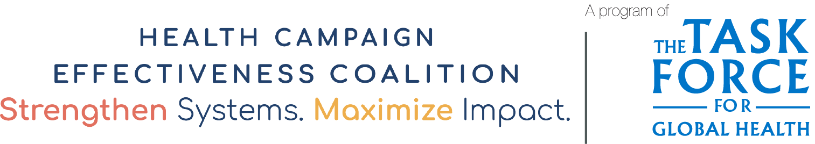

Caregiver Awareness Survey
Conduct interviews of about 20 caregivers of children less than 5 years in the community or sub-district assessed in the Preparedness Checklist is located to evaluate the level of awareness of the campaign. If 20% or more of caregivers (4+) do not know about the campaign, inform the district and the sub-district to strengthen social mobilization in the area.
Region:_____________ District:____________________ Sub-district:__________________ Community:______________

Respondents | Is the caregiver aware of the campaign? |  | Does the caregiver know the dates for the campaign? |  | How did the caregiver become aware of the campaign?
 | Yes | No | Yes | No | 1. TV  2. Radio  3. Community info center  4. Public announcement  5. Health worker | 6. Volunteers  7. Religious leader  8. Opinion leader  9. Text Message  10. Other (Specify)
Caregiver 1
Caregiver 2
Caregiver 3
Caregiver 4
Caregiver 5
Caregiver 6
Caregiver 7
Caregiver 8
Caregiver 9
Caregiver 10
Caregiver 11
Caregiver 12
Caregiver 14
Caregiver 15
Caregiver 16
Caregiver 17
Caregiver 18
Caregiver 19
Caregiver 20
TOTAL
PERCENTAGE

Acknowledgements
Adapted with gratitude from tools developed by UNICEF Ghana and Ghana Health Services (GHS) as part of an integrated polio vaccination and vitamin A supplementation campaign. UNICEF Ghana and the GHS’s original case study and report, developed with the support of the Health Campaign Effectiveness Program, can be found here: https://campaigneffectiveness.org/research_project/lessons-from-the-integrated-campaign-of-mono-oral-polio-vaccine-type-2-mopv2-and-vitamin-a-supplementation/

