Guidelines for Integrated Vaccination and Vitamin A Teams
These sample guidelines provide instructions for an integrated poliovirus vaccination (mOPV2) and vitamin A supplementation campaign in the context of the COVID-19 pandemic. You can update these guidelines to meet the needs of your integrated campaign.

Teams
▪ Each team is composed of 2 members: one vaccinator and one volunteer.
Team Member 1
▪ Carries mOPV2 vials with frozen ice packs in vaccine carrier
▪ Carries Vitamin A capsules (100,000 IU/200,000 IU)
▪ Vaccinates children with mOPV2
▪ Doses children with Vitamin A as appropriate with age (100,000 IU=6-11 months & 200,000 IU=12-59 months)
▪ Keeps empty vials in a separate carrier bag/Ziplock
▪ Monitors ice packs and vaccine vial monitor (VVM) status of vaccines (see page 3)
Team Member 2
▪ Announces arrival of team
▪ Asks for all children under 5 years of age
▪ Fills tally sheets (separately for mOPV2 and Vitamin A)
▪ Keeps tally sheets clean/tidy
▪ Marks the base of the right little fingernail of all vaccinated children with indelible marker
▪ Marks houses - R2 without a circle around it (if you have to revisit the house)
▪ Marks houses - R2 a circle around, if all children in the house are vaccinated
▪ Asks about any case(s) of weakness in limbs (acute flaccid paralysis (AFP)) of children <15 years and report
▪ Reminds mothers/caregivers to continue with routine childhood services
▪ Reminds caregivers about hand washing with soap under running water and/or use of hand sanitizers
▪ Reminds caregivers to avoid crowded places and wear face masks always in public places as a measure to prevent COVID-19
Each Team Should Have
▪ A map showing catchment areas and their movement plan
▪ Total number of children targeted for the campaign
▪ Targeted number of children for each day (based on microplan)
▪ Vaccine carrier with 4 frozen ice packs with foam
▪ Hand sanitizer(s) and 2 face masks per team member per day
▪ Adequate quantity of mOPV2 with droppers (daily target + 10% extra for all logistics)
▪ Adequate quantity of Vitamin A (both 100,000 IU and 200,000 IU capsules) in a pack with scissors
▪ Pieces of chalk (4 white and 2 colored per team per day) to mark houses visited
▪ Pencils/pens for recording on tally sheet
▪ Indelible markers to mark children who have been vaccinated
▪ Enough tally sheets (average of two per team per day for both)

Every day, before starting, the team should check the following:
▪ Route plan for the day
▪ Targeted number of children for the day
▪ Number of houses to be re-visited
▪ Any other information from the team supervisor
On entering a house:
▪ Introduce the team and explain the purpose of the visit
▪ Sanitize your hand before and after vaccinating EACH child
▪ Assure caregivers that repeated doses of polio vaccine are beneficial and not harmful
▪ Indicate the place of visit on the tally sheet and enquire about all children less than 5yrs in household including visitors
▪ Give two drops of mOPV2 to every child under 5 years
▪ Mark the base of the right little fingernail of children vaccinated
▪ Arrange a time to revisit a house if there is any child less than 5 years in the household who could not be vaccinated
▪ Ask for children aged 0-15 years with weakness in the limb/limbs occurring within the last 4 weeks (if yes complete AFP information on tally sheet and notify supervisor)
Before leaving a house the team:
▪ Asks about any case(s) of weakness in limbs (AFP) of children less than 15 years and report
▪ Reminds mothers/caregivers to continue with routine childhood services including Vitamin A supplementation
▪ Reminds caregivers about hand washing with soap under running water and/or use of hand sanitizers
▪ Reminds caregivers to avoid crowded places and wear face masks always in public places as a measure to prevent COVID-19
▪ Marks the house R2 with no circle if there are some children less than 5 years who have not been vaccinated
▪ Marks the house R2 with a circle around it if all children less than 5 years have been vaccinated
▪ Informs caregivers to report to the nearest health facility if he/she observes any adverse event after vaccination
▪ Makes arrangements for a revisit as soon as possible, if the house was not fully completed
▪ Thanks parents/caregivers for their cooperation
At the end of the day the team should
▪ Complete other information on both tally sheets including houses to revisit
▪ Report to supervisor and review performance. Were targets met?
▪ Report on any difficulties and plan solutions with the supervisor
▪ Discuss the next day’s activities including revisits with the supervisor

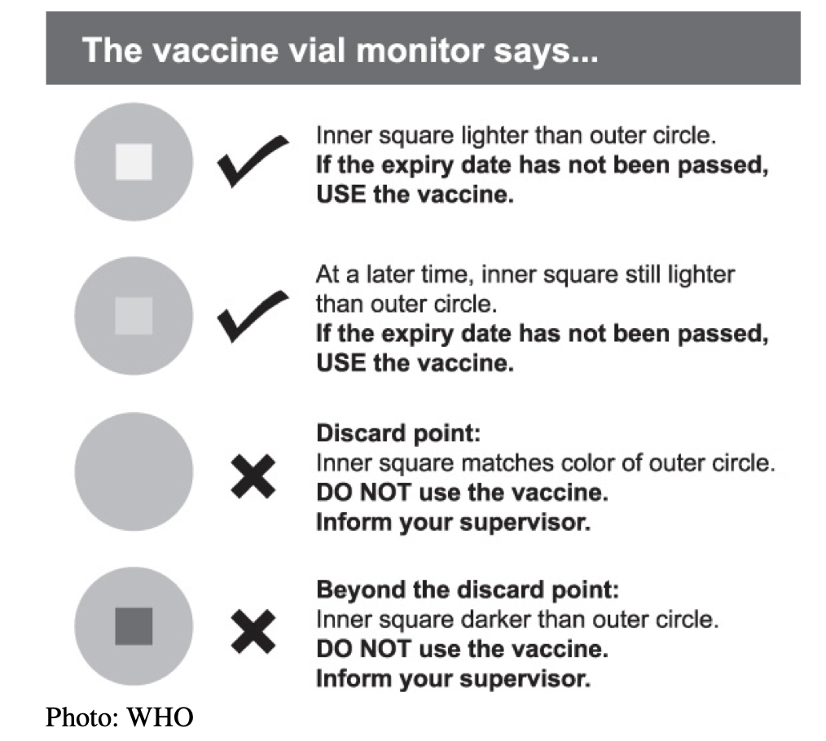

POINTS TO REMEMBER WHEN CONDUCTING HOUSE–TO-HOUSE VISITS:
In conducting house-to-house visits:
▪ Enquire about all children under 5 years and provide them services
If all children less than 5 years in a house are not reached with service:
▪ Plan revisit with relatives or neighbors
In markets, schools, streets, hospitals, churches, mosques, farms, etc.:
▪ Vaccinate all children under 5 years seen
▪ Dose with Vitamin A appropriately (100,000 IU for 6-11 months & 200,000 IU for 12-59 months)
Ensure quality of vaccine:
▪ Always keep vaccines in vaccine carrier with frozen ice packs
▪ Do not use vaccines with VVM at Discard Point or Beyond Discard Point.
▪ Do not use vaccines without labels
▪ Check the expiry date of vaccines (NB: Do not use expired vaccines)
Ensure you retrieve all vaccines:
∙ Ensure accountability of all vaccines daily
o Empty vials
o Opened vials (partially used)
o Unopened (irrespective of VVM stage)
o Broken vials

Acknowledgements
Adapted with gratitude from a tool developed by UNICEF Ghana and Ghana Health Services (GHS) as part of an integrated polio vaccination and vitamin A supplementation campaign. UNICEF Ghana and the GHS’s original case study and report, developed with the support of the Health Campaign Effectiveness Program, is available here: https://campaigneffectiveness.org/research_project/lessons-from-the-integrated-campaign-of-mono-oral-polio-vaccine-type-2-mopv2-and-vitamin-a-supplementation/

