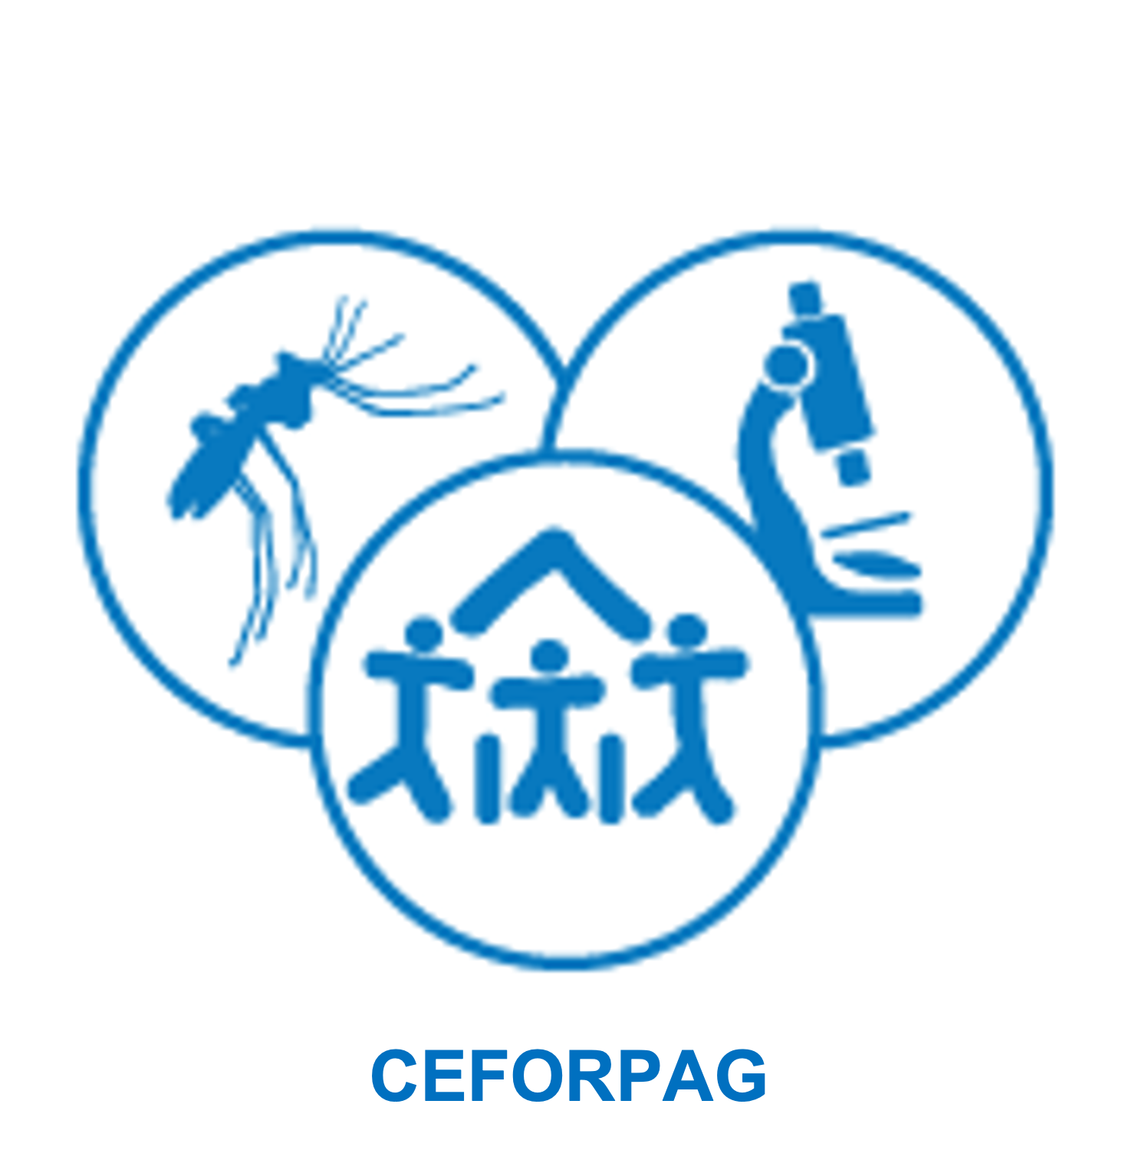
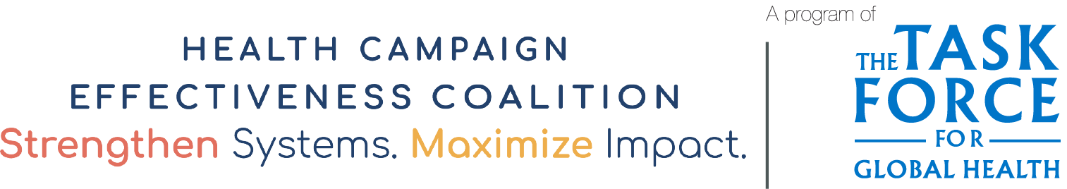

Community Perceptions of Integrated Health Campaigns - Sample Interview Guide
This interview guide can be used to engage communities about their experience with and perceptions of campaign integration. Use it as a starting point to develop your own focus areas and questions.
Questions | Interview Notes
What is the community's involvement in planning health campaigns?

To what extent will the integrated campaign meet the needs of the community?

What do you think will be the benefit of integrating health campaigns?
Questions | Interview Notes
What do you think will be the disadvantages of integrating health campaigns?

What is community involvement in social mobilization and communication about health campaigns?

Acknowledgements

Adapted with gratitude from a document developed by FOSAD-CEFORPAG as part of a study of collaborative planning for a measles and meningitis A vaccination integrated campaign in Guinea. FOSAD-CEFORPAG’s case study and report, developed with the support of the Health Campaign Effectiveness Program, is available here: https://campaigneffectiveness.org/research_project/improving-the-effectiveness-of-an-integrated-measles-and-meningitis-a-immunization-campaign-in-the-context-of-multiple-epidemics/

