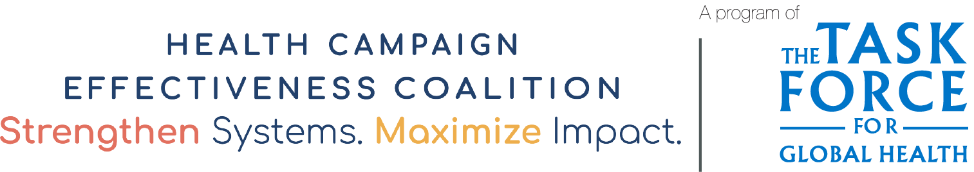
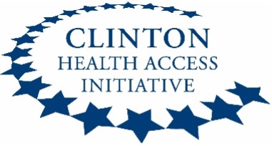
Partner Integration Experiences Sample Interview Questions
This list of questions can be used to develop a customized interview guide to engage stakeholders about their experience with and perceptions of campaign integration. Use it as a starting point to develop your own focus areas and questions; keeping in mind the length of your interviews and assessing the appropriate number of questions.

Primary research question: What is the impact of campaign integration on coverage?
*Secondary questions may relate to integration of specific campaigns in your country.
- General Overview
- From your experience, what is your assessment of the approaches to integrated campaign programs?
- What do you consider as the most challenging aspect of integration?
- How was your organization involved in and/or informed about the plan to integrate campaigns? What were the perceptions of integration?

- Pre-Planning
- Tell me about the collaborative pre-planning process for integrated campaigns.
- Has your organization supported a stand-alone campaign? How was the pre-planning of the integrated campaign different from a standalone campaign?
- What roles did you and your organization play as a collaborative partner with the government?
- Are there challenges with the integrated campaign planning process at the national level? Can you mention a few?
- In what ways can the pre-planning process be improved at the national level and cascaded to the states?

- Planning and Coordination
- What kind of national coordinating body was established to oversee the integrated campaign, if any? Was your organization part of this working group? In what ways were the meetings conducted?
- What were the benefits of the joint coordination of integrated campaigns? What challenges were faced?
- What were your responsibilities for the coordination and implementation of integrated campaigns?
- What are the challenges and opportunities related to collaborative micro-planning?
- What were the enablers and barriers at various levels of the health system that affected the initiation of integrated campaigns?
- What capacity building/training processes for the integrated campaign did the national system adopt and how was this duplicated in the states?
- Are there any improvements or changes you can suggest?

- Microplanning
- Was microplanning training at the national and state level? What organization(s) led training?
- Was the microplan template integrated to capture all health intervention data or were microplans for different interventions standalone? If it was, how did this harmonization help in the planning process?
- Has your organization supported a stand-alone campaign? What processes are involved in stand-alone campaign microplanning?
- What is the timeline for microplanning? What specific activities take place from the planning, validation, verification, and submission process of the microplan?
- What variables do you suggest should be added to an integrated microplan template?
- Are there any improvements or changes you can suggest?

- Financing
- How were activities for the integrated campaign budgeted? Was there clear delineation and budget lines for integrated and standalone planning activities?
- How were the cost of health supplies (e.g., vaccines, drugs, bednets) and the cost of integrated campaigns financed (e.g., Ministry of Health, Gavi)?
- Did your organization provide the national or state program with financial or technical support? How was the allocation of funds determined?
- What factors were used to determine cost-sharing (budgeting) between campaigns?
- What funding challenges were experienced? Did these challenges differ in integrated campaigns vs. standalone?
- Are there any improvements or changes you can suggest?

- Cold Chain and Logistics
- Do you perceive the storage capacity for health commodities (e.g, vaccines, drugs, supplies) is adequate at various levels? What is the condition of the available cold chain equipment at various levels?
- What concerns did the national program have to consider before distributing commodities to states?
- What was the national level distribution plan for commodities and what was the process?
- What were the challenges of commodity distribution?
- What priority interventions do you think can be put in place to improve the distribution of commodities?
- How did the national program handle logistics for the campaign?
- Did the national program have to expand storage capacity/cold chain/transportation systems to accommodate integrated campaigns? What components were expanded? Were any challenges encountered? If so, what?
- Were different storage/cold chain/transportation systems used for different health commodities?
- How did the national program ensure that adequate data tools, vaccination cards, etc. were available to states before the campaign?
- How adequate were storage capacity/cold chain/transportation systems and other logistics compared to a standalone campaign?
- Are there any improvements or changes you can suggest?
- Supportive supervision
- What role do you think supportive supervision plays in strengthening integrated campaign planning?
- Did the campaign adopt an integrated approach to monitoring and supervision? Was a joint checklist developed for supervisors?
- What identifiable challenges does the national program face in conducting supervision at the state level?
- What monitoring and evaluation timelines and reporting lines were provided to the state by the national level? How did the national level ensure that data were reported on time? How did the national level provide feedback?
- What priority interventions can be taken to improve supportive supervision at the national level?
- What was the source of funding for the supportive supervision and monitoring & evaluation?
- What data collection tools were used during the integrated campaigns? Are these data collection tools the same for standalone campaigns?
- Are there any improvements or changes you can suggest?

- Social Mobilization and Communication
- Was there a joint communication plan for the integrated campaign? If so, how were they integrated to appeal to the integrated campaign beneficiaries?
- Was the advocacy plan for high-level decision-makers integrated?
- Did the social mobilization plan capture messages for all health interventions?
- Were there any challenges to social mobilization funding?
- In your opinion, what messages were the strongest, and which form of media would you consider most effective and least effective?
- Were assessments carried out to identify if beneficiaries/caregivers had concerns relating to integrated campaigns? How was this data collected? What concerns were identified?
- Are there any improvements or changes you can suggest?

- Adverse Event (AE) Surveillance
- At what stage were materials for AE procured and prepositioned at the state for the integrated campaign?
- How did the national level determine how AE cases would be monitored and treated? Is this the same method used for standalone campaigns?
- Were any AEs reported? How were they handled? Were AEs adequately reported to the national level?
- How effective was communication for reporting AEs?
- What challenges did the national experience in supporting the states with AEs?
- Are there any improvements or changes you can suggest?

- Waste Management Plan
- Was the waste disposal method for the integrated campaign the same as standalone?
- Was a cost integrated waste management plan developed?
- What were the major causes of waste? Were there any challenges in disposing of additional waste resulting from integration (e.g., vaccine vials, syringes etc.)
- In what ways did the national level ensure that waste management was adequate at the state level?
- Are there any improvements or changes you can suggest?

Acknowledgements

Adapted with gratitude from a document developed by CHAI as part of an evaluation of a measles and meningitis A integrated campaign in Nigeria. CHAI’s case study and report, developed with the support of the Health Campaign Effectiveness Program, is available here: https://campaigneffectiveness.org/research_project/lessons-learned-from-measles-and-meningitis-a-integrated-campaigns-in-northern-nigeria/

